**Genome replication**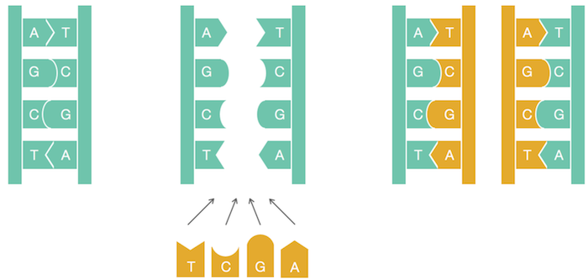

**Hidden Message Problem:** Find a “hidden message” in the replication origin.  
     **Input**: A string Text (representing the replication origin of a genome).  
     **Output**: A hidden message in Text.

**PatternCount**(*Text*, *Pattern*)

*count* ← 0

**for** i ← 0 to |Text| − |Pattern|

**if** *Text*(*i*, |*Pattern*|) = Pattern

*count* ← *count* + 1

**return** *count*

**Frequent Words Problem:** Find the most frequent k-mers in a string.  
     **Input**: A string Text and an integer k.  
     **Output:** All most frequent k-mers in Text.

**FrequentWords**(*Text*, *k*)  
*FrequentPatterns* ← an empty set  
**for** *i* ← 0 to |*Text*| − *k  
Pattern* ← the *k*-mer *Text*(*i*, *k*)  
*Count*(*i*) ← **PatternCount**(*Text*, *Pattern*)  
*maxCount* ← maximum value in array *Count***for** *i* ← 0 to |*Text*| − *k***if** *Count*(*i*) = *maxCount* add *Text*(*i*, *k*) to *FrequentPatterns* remove duplicates from *FrequentPatterns* **return** *FrequentPatterns*

**Code Challenge:** Solve the Frequent Words Problem.  
     **Input:** A string *Text* and an integer *k*.  
     **Output:**All most frequent *k*-mers in *Text*.

**complementary strand** on a **template strand**.

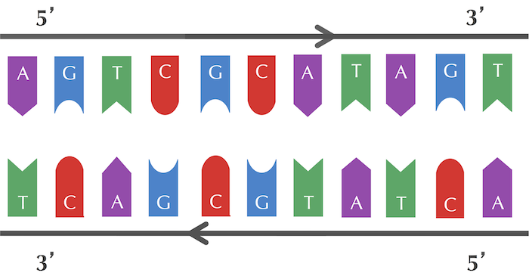

**Reverse Complement Problem:** Find the reverse complement of a DNA string.  
     **Input**: A DNA string Pattern.  
     **Output**: Patternrc, the reverse complement of Pattern.

**Clump Finding Problem:** Find patterns forming clumps in a string.  
     **Input**: A string Genome, and integers k, L, and t.  
     **Output**: All distinct k-mers forming (L, t)-clumps in Genome.

**Clump Finding Problem:** Find patterns forming clumps in a string.  
     **Input**: A string Genome, and integers k, L, and t.  
     **Output**: All distinct k-mers forming (L, t)-clumps in Genome.